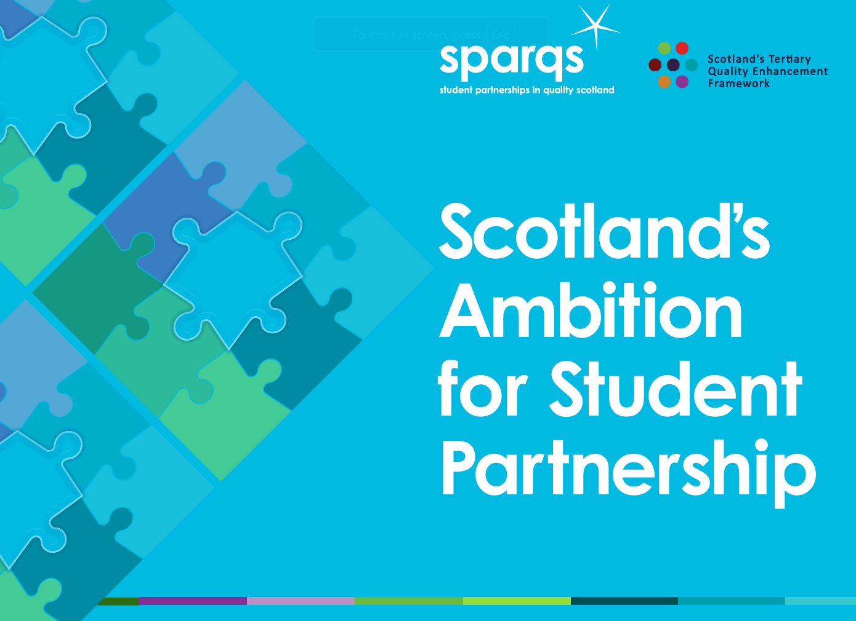
Enhancing student partnership

at course, programme or institutional level #6

Self-Directed activity

You might like to print or save this document so that you can use it as a worksheet for making your own notes.

Intended Learning Outcomes
By the end of this activity you should be able to:
- Reflect on ‘students as partners’ approaches embedded within your unit, course, module, programme or institution.
- Identify an area of practice that you wish to enhance using a ‘students as partners’ approach.
- Draft initial ideas for a related enhancement activity using Scotland’s Ambition for Student Partnership (in preparation for subsequent discussion and refinement during a team/group based session with your colleagues and students).

Format
- Asynchronous resource.
- 30 minutes, self-directed activity.

Intended audiences
- Students’ association staff and elected officers.
- Staff members with responsibility for the curriculum or quality at unit/course/ module, programme or institutional level (e.g. Course Leaders, Programme Leaders, Curriculum Managers, Quality Teams, Academic Development Teams).
- Programme teams (e.g. preparing for validation/review or ILQR activities).
- Senior leaders (e.g. responding to persistent issues from NSS or SSES data).

Note: This self-directed activity is ideally undertaken in advance of a team/group session. The aim of this activity is to prompt individual reflection, prioritisation and draft planning in advance of further discussion and refinement during a group session with colleagues and students.

Acronyms
- ILQR = Institution-led Quality Review (formerly Institution-led Review)
- NSS = National Student Survey (universities)
- sparqs = student partnerships in quality Scotland
- SSES = Student Satisfaction and Engagement Survey (colleges)

Mapping to Professional Standards

Professional Standards for Lecturer’s in Scotland’s Colleges (GTCS): 1.1.2; 1.2.1/2/4; 1.3.2/4/5; 2.2.1/2/5/11; 2.5.1/3/4/6; 3.1.2; 3.2.1/2/4; 3.3.2/3; 3.5.2
Professional Standards Framework 2023 (PSF 2023) (Advance HE): V1, V3, V5, K1, K2, A1, A2

Copyright

Licensed under a Creative Commons Attribution Non-commercial 4.0 licence.
You are free to copy, communicate and adapt the work, so long as you attribute sparqs.

Who are sparqs?

sparqs stands for ‘student partnerships in quality Scotland’.

We’re a Scottish sector agency and charity, with full-time staff based in Edinburgh. We work with students and staff in all institutions and students’ associations across the Scottish university and college sector, and our main funding comes from the Scottish Funding Council (SFC). You can find out more about us through our website.

Contact us

If you have questions or would like to provide feedback on this resource (or other resources within the Academic Development Toolkit) please don’t hesitate to get in touch with Prof Catriona Bell, sparqs External Consultant – catriona.bell@sparqs.ac.uk

Self-directed activity

Reflect on current practice (10 mins)
- Briefly list concrete examples of how you/your team have successfully worked in partnership with students at unit/course/module, programme or institutional level.
Example | Why was this introduced? | What role do students have in this? | What role do  you/your team have in this?

Identify an area for future enhancement (10 mins)
- Select one priority area at unit, course, module, programme or institutional level that you would like to enhance using a ‘students as partners’ approach.
- Consider why you have chosen this (e.g. what evidence or data is available to you?).

Your notes:

Draft initial plans for an enhancement activity using Scotland’s Ambition for Student Partnership (10 mins)
- Scan Scotland’s Ambition for Student Partnership, paying particular attention to the Ambition on page 2, and Features of Student Partnership on pages 3 & 4. Identify the feature(s) that relate most closely to your chosen area for enhancement.
Your notes:

- Select indicators of practice from the relevant feature(s) that will help you to explore and enhance this area of practice further using student partnership approaches.
Your notes:

- Draft initial plans and associated timescales for undertaking this enhancement activity. (Relevant prompt questions might include: When, Where, Who, How?).
Your notes:

Follow-up activities:
- Identify potential measures of impact for your enhancement plan – how will you know that it has been successful?
- Arrange a team-based session to discuss your individual enhancement plan ideas, and then negotiate and agree priorities as a team moving forwards.
- Facilitate* a workshop for your team and your students using this Session Plan – ‘#9 Co-creating an Enhancement Plan for student partnership (at course, programme or institutional level)’.
(*or make plans for an appropriate colleague to facilitate a workshop)
- After implementing your enhancement plan: discuss and reflect on the findings with your team and your students. Refine your enhancement plan further for future years. Consider the following questions, ‘So What?’ and ‘What next?’

Worked example

Reflect on current practice (10 mins)
- Briefly list concrete examples of how you/your team have successfully worked in partnership with students at unit/course/module, programme or institutional level.
Example | Why was this introduced? | What role do students have in this? | What role do  you/your colleagues have in this?
Example 1:  Timetabled ‘Mid-module check-in’ sessions for all courses in Programme X. | Create space for dialogue with all students in cohort.  Gather mid-module feedback - may inform immediate enhancements for the cohort (where feasible).  Empower students to suggest solution-based and enhancement-focused ideas. | In advance (course rep co-ordinates this): use online whiteboard to create student-led agenda + share interim feedback and suggestions for enhancement of module.  During session: Engage in dialogue with staff based around agenda + suggestions on whiteboard. | During session: Actively listen to students’ feedback + suggestions; engage in dialogue to deepen understanding.  Collate student feedback and staff responses. Feed into annual monitoring & enhancement planning.
Example 2:  Recruiting volunteers to undergo hair and beauty treatments during Monday classes at Campus Y. | Students cannot practice hair and beauty treatments on their classmates, and we have a shortage of volunteers for treatments on Campus Y on Mondays.  We invited our hair and beauty student to develop solutions-based approaches to resolving this issue. | Students create and deliver a campaign via posters and socials to recruit additional student volunteers from a different course at Campus Y.  Students created and managed a student-friendly booking system for treatments which is still in use. | Course Leader identifies which other courses are taught on Campus Y on Mondays.  Course Leader plans the numbers of volunteers required for each class.  Course Leader has oversight of the content of the socials campaign before it’s launched.

Identify an area for future enhancement (10 mins)
- Select one priority area of your unit, course, module or programme that you’d like to enhance using a ‘students as partners’ approach.
- Consider why you’ve chosen this (e.g. what evidence or data is available to you?).
Your notes:
Supporting student parents to succeed on our programme.
Why?
  - Poor retention rates – Over last 3 years, 30-40% of student parents have withdrawn within the first 6 weeks of their programme.
  - Poor attendance rates at scheduled classes, particularly Friday afternoon classes.
  - Informal feedback regarding timetabling challenges received by course tutors.

Make initial plans for an enhancement activity using Scotland’s Ambition for Student Partnership (10 mins)
  - Scan Scotland’s Ambition for Student Partnership, paying particular attention to the Ambition on page 2, and Features of Student Partnership on pages 3 & 4. Identify the feature(s) that relate most closely to your chosen area for enhancement.
‘Diversity of student voices’ and ‘Solution focused’
- Select indicators of practice from the relevant feature(s) that will help you and your colleagues explore and enhance this area of practice further in partnership with your students.
Your notes:
Indicators of Practice
- Partnership activities and mechanisms are designed to be accessible to all students to the greatest extent possible. This may include considerations of timing, location, cost, and mode of engagement (e.g. online/in-person).
- Partnership activities with students focus not just upon addressing inequalities and removing barriers to learning, but on actively enriching the wider student experience and valuing the ideas that diverse individuals bring.
- There are multiple opportunities for students to engage with partnership processes at a level that suits them. Students can choose to take part in engagement activities, such as filling in a survey or contributing to a focus group, as well as taking on more substantial roles.
- Evidence of solution planning incorporates diverse voices and needs of students and there is a breadth of solutions to meet the diverse needs of students.

- Draft initial plans for undertaking this enhancement activity. (Some relevant prompt questions might include: When, Where, Who, How?).
Your notes:
Who?
  - Identify 2 or 3 student parents within cohort, instigate informal conversation to identify optimum options for ‘Where’ and ‘When’ for a student parent consultation session.
  - Alternatively (probably a better option)– explain rationale for enhancement activity and show QR code at end of class for student parents to vote for most convenient date/time/location.
Where?
- Offer multiple options – consultation session in child-friendly location on campus? Online consultation session? Survey via QR code?

When?
- Offer multiple options - at end of timetabled class, evenings, avoid Friday afternoons (as schools off).
How?
- Programme Leader to plan session in partnership with course rep, or volunteer student parent, or Student Support team member. Agree who would be best person to facilitate discussion group (to encourage engagement & responses)
- Programme Leader to investigate potential options for providing nursery/creche facilities during student parent consultation session.
- Invite student parents to propose and facilitate a range of potential solutions for identified challenges.
- Identify and celebrate particular strengths and skills of student parents, e.g. time management, life hacks for efficient studying.

